**Chapter Four**

**Proposed Intelligent Features**

# Introduction

Presented adaptive e-Learning models shed lights on supporting e-Learning with intelligent features. Intelligence can be addressed in different aspects of the proposed models. This chapter presents detailed design of the intelligent features to improve students’ performance and help instructors through the e-Learning process. Those goals can be achieved by applying different technologies available to educational institutions, instructors and students in an innovative way. Different intelligent services are presented to enable the intelligent features. Generally, an intelligent service is presented for each intelligent feature. Presented intelligent services can be grouped into two categories based on their users. Figure 4.1 presents the two proposed intelligent services’ categories: Instructor Intelligent, and Student Intelligent Services.

**The Instructor Intelligent Services are:**

* Intelligent Learning Object (LO) Classifier
* Intelligent Online Lecture LOs Advisor
* Intelligent Student Tracker
* Intelligent Cheat Depressor

**The Student Intelligent Services are:**

* Intelligent Study Plan Advisor
* Intelligent Time-to-Learn Topic Calculation
* Intelligent LOs Recommender
* Intelligent Agenda Study Time Planner
* Intelligent Meeting Manager for Suspended Students

Figure 4.1: Proposed Intelligent e-Learning Features

From Adaptive e-Learning Model, intelligent features are:

* Students are grouped. Each group is delimited by the same start date. Students that do not catch this start date are delayed to the next group, which is 15 days later.
* Crawlers keep searching the internet for newly and updated Learning Objects, besides instructors add different resources to the LOs repository. **Intelligent Learning Objects Classifier** is used to classify found LOs.
* Learning goals are identified by instructors. Based on these learning goals, instructors define learning paths. Instructors can make some branching at certain points to give students the flexibility to customize their learning paths. **Intelligent Study Plan Advisor** helps students at those points.
* **Intelligent Time-to-Learn Topic Calculation** is the service that is used to advice students about the time needed to study a certain topic. Based on students study time of previous topics and the available LOs for this topic, this service can intelligently advise students about the study time issue.
* Students attend one or more adaptive online lecture within the same learning goal. Adaptive online lecture makes use of the **Intelligent Online Lecture LOs Advisor** to recommend LOs for the instructor to use during the lecture, based on the students’ learning profiles.
* **Intelligent LOs Recommender** is the intelligent service that will recommend LOs for students based on their learning profiles. Recommended LOs list is approved by the instructor and reordered based on the students’ preferences.
* **Intelligent Agenda Study Time Planner** is used to organize the students’ time tables and organize their different activities by connecting them to different activities available in the university based on their preferences through announcements.
* **Intelligent Student Tracker** service is used to track the students’ performances during the online learning journey, and to verify the completeness of students’ learning profiles. Peaks and performance degradation in students’ performances need to be recorded and studied.
* Learning path is marked by different learning checkpoints. At each checkpoint, students attend an online exam. Those who pass will continue the learning path. Those who fail will have to re-attend the exam within 4 days. If they fail again, they will have to re-attend the exam within 2 days. If they do not pass the third time, they are suspended.
* **Intelligent Meeting Manager for Suspended Students** service is responsible for managing a meeting between an instructor and the suspended student to handle the learning issues that prevent student from coping with student’s group. Suspended students drop behind their group.
* **Intelligent Cheat Depressor** service focuses on utilizing intelligent techniques in prohibiting students from cheating. When combining both Intelligent Student Tracking service, and Intelligent Cheat Depressor service, cheating instances might be identified.

# Instructor Intelligent Services

The intelligent services that aim to help instructor through teaching are: Intelligent LOs Classifier, Intelligent Online Lecture LOs Advisor, Intelligent Student Tracker, and Intelligent Cheating Depressor.

## Intelligent LOs Classifier

Different intelligent techniques can be utilized in classifying LO based on LO type. Classifying multimedia-based LOs can be via meta-data, tags, and annotations, while classifying text-based LOs can be done through accessing and analysing content. Text classification or categorization is the process of organizing information logically. It can be used in many fields such as document retrieval, routing and clustering. Document classification tasks can be divided into two sorts: supervised document classification where some external mechanism - such as human feedback - provides information on the correct classification for documents. The second sort is unsupervised document classification, where the classification must be done entirely without reference to external information. Presented Intelligent LOs Classifier utilizes two of the supervised document classification algorithms: Naïve Bayes Classifier, and Term Frequency – Inverse Document Frequency (TF-IDF) algorithms. Both belong to probabilistic classifiers.

## Intelligent Online Lecture LOs Advisor

Intelligent Online Lecture LOs Advisor accesses students’ profiles and learning preferences side by side with data from previous online lectures and course specification data. This service provides the instructor with a recommended list of LOs based on the attending students. This list can be used during the lecture. Table 4.1 presents Intelligent Online Lecture LOs Advisor specifications, and figure 4.2 presents its detailed flow diagram.

Table 4.1: Intelligent Adaptive Online Lecture LOs Advisor Specifications

|  |  |
| --- | --- |
| Input | |
| Student Preferences | Different learning preferences that identify the student learning behavior are stored. Those preferences are considered for identifying different study plans. |
| Related LOs Specifications | LOs satisfy students’ classes by percentage. The higher available LOs that match students’ preferences, the higher this topic is recommended for teaching. |
| Learning Topics Data | Data about courses and topics to be pedagogically used in learning scenarios. |
| Previous Online Lectures Data | LOs that were used by previous instructors during online lectures for the same topic and students’ feedback for those LOs are important data for this recommendation process. |
| Processing | |
| By assigning different Weights to the different inputs, fuzzy logic is used to generate a weighted list summary report. The intelligent advisor does the following:   * Identify LOs presented at previous lectures * Fuzzily classify attending students to one of the learning styles * Check the LOs specifications and meta-data * Identify the most suitable LOs to use with attending students | |
| Output | |
| Recommendation Report | Instructor can use this report to identify Los suitability. |

  
**Figure 4.2: Intelligent Online Lecture LOs Advisor Flow Diagram**

## Intelligent Student Tracker Service

This service tracks student behaviour and assures that there is a complete learning profile that helps the system identifies the student’s learning preferences and styles all-over the system. Learning style is the individual’s characteristic ways of processing information and behaving in learning situations. Knowledge of learning styles can help instructors better understand learners and have important implications for program planning, teaching, and learning. For each student, there will be four different learning styles available to form the student learning preferences. Student learning styles are:

1. General
2. Felder
3. ATLAS
4. Brain Works

### General Learning Style

During registration, students are asked to complete general learning style preferences. In case the student selects more than one style, student is asked to rank choices, so later recommendations can define to what extent it is fulfilling the student’s requirements. General Learning Profile Preferences are:

* **Visual:** Individuals that learn best when ideas or subjects are presented in a visual format, whether that is written language, pictures, diagrams or videos are visual learners.
* **Auditory:** Individuals who learn best by participating in class discussion, by listening to teacher lecture, listening to audio tapes or by listening to other language formats are Auditory Learners.
* **Tactile:** Tactile Learners are hand-on learners. They learn best when they are able to physically participate directly in what they are required to learn or understand.
* **Logical:** Logical learners like using brain for logical and mathematical reasoning. Logical learners can recognize patterns easily and are good at making logical connections between what would appear to most people to be meaningless content.
* **Social:** Social learners communicate well with others. They are good listeners and are able to understand other's views.
* **Solitary:** Solitary learners tend to be private, introspective and independent. They are able to concentrate and focus on a specific subject, topic or concept without outside help.

### Felder Learning Style

Felder Learning Model can be identified by promoting the student to answer questions that help identifying the student’s learning preferences. Though Felder identifies that the student is middle between different models, Felder model can help the system to identify the student learning features, and prepare the most appropriate learning environment. Felder Learning Model categories are presented in table 4.2, and they include:

* Active and Reflective
* Sensing and Intuitive
* Visual and Verbal
* Sequential and Global

Table 4.2: Felder Learning Style Categories Description

|  |  |  |
| --- | --- | --- |
|  | Category | Description |
| Category | Active | Tend to retain and understand information best by doing something active with it, like discussing or applying it or explaining it to others. Tend to work in group. |
| Reflective | Prefer to think about things first. Prefer working alone. |
| Category | Sensing | Like learning facts, solving problems by well-established methods, dislike complications and surprises. Tend to be patient with details and good at memorizing facts and doing hands-on (laboratory) work. |
| Intuitive | Prefer discovering possibilities and relationships. Like innovation and dislike repetition. Better at grasping new concepts and are often more comfortable with abstractions and mathematical formulations. |
| Category | Visual | Remember best what they see: pictures, diagrams, flow charts, time lines, films, and demonstrations. Most people are visual learners. |
| Verbal | Get more out of words--written and spoken explanations. |
| Category | Sequential | Tend to gain understanding in linear steps, with each step following logically from the previous one. Tend to follow logical stepwise paths in finding solutions. |
| Global | Global learners tend to learn in large jumps, absorbing material almost randomly without seeing connections, and then suddenly "getting it." Able to solve complex problems quickly or put things together in novel ways, but they have difficulty explaining how did they got it. |

### ATLAS Learning Style

ATLAS Learning Model can be identified by promoting the student to answer questions that help identifying the student’s learning preferences. ATLAS learning model categories are:

* **Navigator:** Focussed learners who chart a course for learning and follow it. Initiate a learning activity by looking externally at the utilization of resources that will help them accomplish the learning task and by immediately beginning to narrow and focus these resources. Rely heavily on planning their learning.
* **Problem Solver:** Rely on critical thinking skills. Like Navigators, Problem Solvers initiate a learning activity by looking externally at available resources; however, instead of narrowing the options available, they immediately begin to generate alternatives. They do not do well on multiple-choice tests because these limit divergent thinking.
* **Engager:** Passionate learners who love to learn, learn with feeling, and learn best when they are actively engaged in a meaningful manner with the learning task, the key to learning is engagement.

### Brain Works Learning Style

Brain Works learning style can be identified by promoting the student to answer questions. Brain Works tries to determine which hemisphere of brain is dominant. It also determines whether the learner react in a more auditory or visual manner. Each of the hemispheres of brain has prescribed functions or specialities. In this manner the brain avoids duplication of function. Hemispheres always work together so that a combination of right and left hemisphere in everything is achieved. There is, however, a tendency for one hemisphere to be dominant. Brain Works learning style categories are:

* Visual vs. Auditory
* Left vs. Right Brain Hemisphere

## Intelligent Cheat Depressor Service

Intelligent Cheat Depressor Service tracks students’ behaviour in Exams and records both: Students’ Marks, and Exam Times trying to identify peaks in marks. Though this service doesn’t detect cheat incidents for certain, however it is used as an indicator to the instructor to track certain students. Table 4.3 presents the details of this intelligent process.

Table 4.3: Intelligent Cheat Depressor Service Specifications

|  |  |
| --- | --- |
| Input | |
| Student’s Previous Exam Data | Data include time consumed by student at each exam, type of exam, and mark scored at this exam for previous exams. |
| Latest Student’s Exam Data | Data include time consumed by student at each exam, type of exam, and mark scored at this exam for the latest exams. |
| Processing | |
| Utilizing Fuzzy Logic to calculate the cheating susceptibility. Threshold range is allowed incase student’s performance is getting better; however peak changes are definitely identified. | |
| Output | |
| Instructor Notification | Informing instructor can take a closer look. |

* 1. **Student Intelligent Services**

Student Intelligent Services are: Intelligent Study Plan Advisor, Intelligent Time-to-Learn Topic Calculation, Intelligent LOs Recommender, Intelligent Agenda Study Time Planner, and Intelligent Meeting Manager for Suspended Students.

## Intelligent Study Plan Advisor

Intelligent Study Plan Advisor is an intelligent advisory service used to help students identify the appropriate study plans by:

* Identify older study plans
* Identify study plans of colleges

Students differ in their learning behaviour and learning preferences. The Intelligent Study Plan Advisor service considers different students as classes based on their learning preferences. Table 4.4 presents the Intelligent Study Plan Advisor specifications, and figure 4.3 presents the detailed flow diagram. In this service, instructors identify branching capabilities in the learning path where students can have the opportunity to study a learning topic.

Table 4.4: Intelligent Study Plan Advisor Service Specifications

|  |  |
| --- | --- |
| Input | |
| Student Preferences | Proposed Model stores different learning preferences that identify student learning behavior. Those preferences are considered for identifying different study plans. |
| Learning Class | Students are grouped into Classes to ease educational tasks. Classes include: Auditory, Visual, and other classes that are discussed in detail in Learning Profile section. |
| Study Plans for Previous Students | Student need to take a closer look on previous instructor plans, grades that students scored by following certain plans, and other data. |
| Study Plans for Colleges | What are students in the same groups are studying now |
| Processing | |
| To generate the Recommended Study Plan, the system utilizes Fuzzy Logic and does the following:   * Identify the class to which the students belong * Check the branching decision that is assigned by instructor for that class, and doubles the weight of this decision * Check the average of branching decision taken by students in the same class * Ranks recommendations from Top-Down based on the generated weights | |
| Output | |
| Recommended Study Plan | Recommended choice to take in the study plan |
| Study Plan for Colleges as an Information | Display hints on what colleges are studying, so student is free to follow their path |

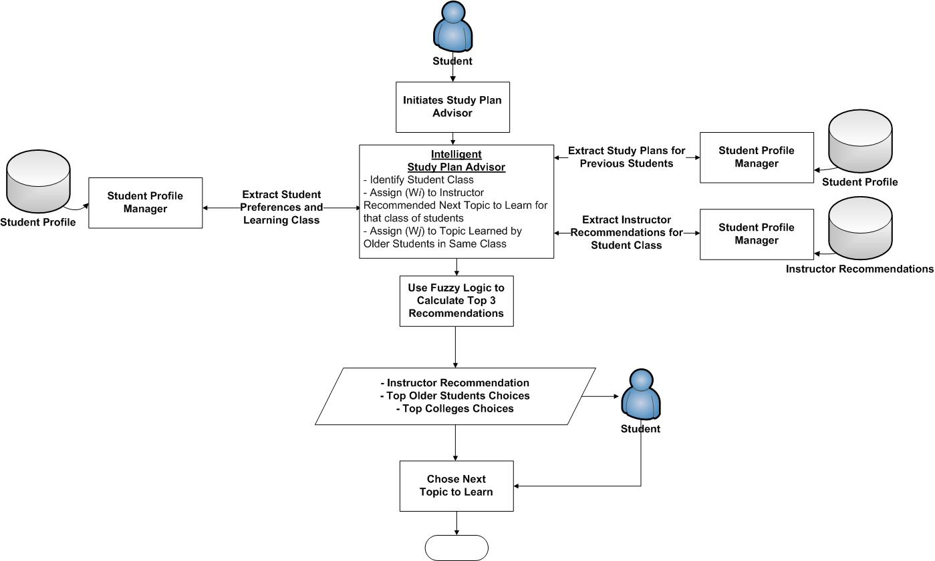

Figure 4.3: Intelligent Study Plan Advisor Flow Diagram

## Intelligent Time-to-Learn Topic Calculation

Intelligent Time to Learn Topic Calculation is an intelligent service that helps students identify time needed to learn a certain topic. From study time point of view, the time needed to study a topic is the summation of the time needed to study LOs composing this topic. The instructors define the learning time for each LO as one of the LOs educational meta-data attributes. The system can identify learning time variances between instructors’ identified learning time and the students actual consumed learning time through tracking students. This time can help student estimate the time needed to finish studying. Table 4.5 presents the Intelligent Time-to-Learn Topic Calculation specifications, and figure 4.4 highlights the service flow diagram.

Table 4.5: Intelligent Time-to-Learn Topic Calculation Specifications

|  |  |
| --- | --- |
| Input | |
| Instructor Defined Learning Time | LO’s author defines learning time for each LO. Later, different instructors can identify learning times for the same LO to match students’ skills. |
| Student Learning Time Shift | Tracking the student’s learning progress helped the system to calculate the time-to-learn shift between the defined time and the student actual time to learn. Average time to learn calculation will be presented. |
| Processing | |
| To calculate Total Time-to-Learn Topic for student, system utilizes Fuzzy Logic in the following process:   * System identifies the LOs list the student must learn to finish the topic based on instructor’s directions * System identifies the time shift between instructor’s identified learning time and the actual time taken by student. Such an entry is identified over time through tracking student. * System estimates time needed for learning each LO, and for all LOs forming Topic, system calculates timed needed to learn that topic. | |
| Output | |
| Time To Learn Topic | Time estimation for student to learn certain topic. |

## 

Figure 4.4: Intelligent Time-to-Learn Calculation Flow Diagram

## Intelligent LOs Recommender

Intelligent LOs Recommender is the service aims to find the most pedagogically suitable LO for helping student learning a topic, then personalizing the recommended list based on student’s preferences. Thus, Intelligent LOs Recommender must efficiently analyze newly introduced LOs, then store information about them for further processing and ordering to each student. From high level view, Intelligent LOs Recommender executes through the two phases presented in Figure 4.5:

* **LOs Finding, Gathering, and Analyzing Phase:** in this phase, system completes different data input resources. Mainly: crawler for supporting open learning environment, digital library data, and students' learning preferences. Web content can be of different types. Audio and video types are identified and handled via annotations that are managed by instructors and learning specialists. Whereas, Information extraction techniques are employed in this process to provide further processing of textual Los.
* **Intelligent Personalized Supervised LOs Recommendation Phase:** in this phase, intelligent fuzzy LOs classifier utilizes fuzzy logic to intelligently discover the degree of relevancy between LOs and specific course specifications. Learning objects that satisfy a specific item of the course with a certain threshold are then recommended. Those recommendations are not considered valid unless they were approved by instructor. After improvement, learning objects are then ranked based on a final score which is a combination of relevancy degrees and user's preferences. Thus, our system guarantees minimum level of pedagogical and learning quality, with a personalization spirit.

Intelligent LOs Recommender phases are interdisciplinary, overloading and it is not easy to set boundaries between them. They must be because they build over each other; they prepare data for processing between them. The two phases are over-viewed in Figure 4.5. Further details about each phase are presented highlighting some of the data and processes required for each phase, and the services that enable the system to achieve those phases.



**Figure 4.5: Personalized Intelligent Recommender e-Learning Overview**

* + - 1. **LOs Finding, Gathering, and Analyzing Phase “Phase One”:**

Extensive amount of data is needed to enable model processing. Different input sources means responsibility in following different input resources and extra effort in completing all input forms. Figure 4.6 presents the steps taken in this phase to ensure as optimal data collection as possible. Four external main data sources for our proposed system must be handled carefully:

* **Internet:** that provides an open learning environment for LOs via Crawler.
* **Digital Library:** that presents different representations of different types of LOs. Digital Libraries provides exclusive information resources that higher in quality and effectiveness when compared to LOs coming from internet.
* **Student Preferences:** in order to be able to personalize the system for each student based on her/his preferences, there shall be a mechanism to inform students with the importance to fill their profiles.
* **Courses' Specifications:** Quality Assurance and Accreditation Project (QAAP) server holds course specifications to be utilized to classify LOs.

The process of Document Processing (divided into two steps) is to make clear the border of each language structure and to eliminate as much as possible the language dependent factors, tokenization, stop words removal, and stemming. Removing stop words and stemming words is the preprocessing tasks. The documents in text classification are represented by a great amount of features and most of them could be irrelevant or noisy. The steps taken for the feature extractions are:

* **Tokenization:** A document is treated as a string, and then partitioned into a list of tokens.
* **Removing stop words:** Stop words such as “the”, “a”, “and”... etc. are frequently occurring, so the insignificant words need to be removed.
* **Stemming word:** Applying the stemming algorithm that converts different word form into similar canonical form. This step is the process of conflating tokens to their root form, e.g. connection to connect, computing to compute.

Next comes the process of text classification. In text classification, a text document may partially match many categories. We need to find the best matching category for the text document. Term Frequency-Inverse Document Frequency (TF-IDF) approach is commonly used to weight each word in the text document according to how unique it is. TF/IDF weights are then fed to fuzzy classifier that specifies to what degree textual content is relevant to a certain category making use of a threshold for more focused and relevant content. Using Fuzzy Logic allows participation of a single learning object in different items in course specifications with different membership degrees.



**Figure 4.6: LOs Finding, Gathering, and Analyzing “Phase One”**

* + - 1. **Personalized Supervised Generated LOs “Phase Two”**

Figure 4.7 presents detailed phase activities. By identifying different information resources, and getting them integrated, Intelligent LOs Recommender can generates a list of LOs that match course specifications based on the former fuzzy classifier. Generated list isn't submitted directly to students to guarantee minimum level of quality and accuracy. This list is appended for instructor to approve / modify it before submitting it. Once instructor approves the list, it becomes available to the student. Second phase entitles ranking those approved LOs based on their relevancy together with their suitability to student's preferences.

* + - 1. **Fuzzy Logic as Intelligent LOs Classifier and Recommender**

Fuzzy Logic is utilized in the two Intelligent LOs Recommender phases: Classification, and Personalization. For system to generate recommendations, it needs to classify a certain Learning Object to an objective in a certain course lecture. However, LO may be related to different objectives, that's why system needs to be flexible enough so that same learning object may belong to different objectives, lectures or courses. That’s why fuzzy classifier was a suitable solution. Fuzzy logic is a form of multi-valued logic derived from fuzzy set theory. In fuzzy set theory, each value represents a degree of probability of membership to a certain set; such value can range between 0 and 1. A Fuzzy set encompass a function to indicate the degree of membership. For the classifier to determine the final membership of LOs, it analyzes both content relevancy as well as user preferences. For any learning to be recommended to user, its membership value must be higher than threshold values. Threshold is used to provide more focused recommendations as can be show in equation 1.

$∀ d∈D$, $∀ o ∈O$, $r=rel\left(d,o\right)$, $r≥ θ$

* d is a learning object
* D: set of all learning objects
* o: specific lecture objective
* O: set of objectives
* r: the degree of relevancy
* $θ$ threshold values

To make fuzzy logic utilization clear in this context, let’s assume that we have Topic (Ta) with set of Keywords = {Ka1,Ka2,…,Kan} and Set of LOs objects={LO1,LO2,…,LOn}. Instructors identify Keywords with relevancy factors, meaning irrelevant keywords have relevancy value of zero, and relevant keywords have relevancy value of one, and other keywords have relevancy values in-between. Recommender utilizes fuzzy logic in identifying the relation between LO and Topic in the following manner:

**Step 1:** Recommender identifies Keywords Composing Topic

**Step 2:** For Each Keyword in Keywords:

* Recommender Searches LOs DB for matching LOs. Matching LOs are stored and retrieved within threshold boundaries and membership values.

**Step 3:** For Each Matching LO:

* Recommender cumulatively and fuzzily calculates the membership of LO to each Topic. Threshold boundaries here, presents LOs as multiply factor of: Percentage of LOs Coverage of this Keyword and Relevancy Factor identified by instructor. LOs are fuzzily evaluated to give weights for instructors’ identified relevancy, and LOs coverage of the keyword.
* Recommender returns a non-ordered list of LOs within threshold boundaries.

**Step 4:** For Each Returned LO:

* Use Fuzzy membership to calculate relationship between LO and learner’s class, and use this membership in ordering LOs list.



**Figure 4.7: Personalized Supervised Automatically Generated LOs List “Phase Two”**

* + 1. **Intelligent Agenda Study Time Planner**

Helps students identify study times, and integrate activities with their agenda to improve performance. It uses the study time shift fuzzily estimated between the instructor LO study time and student actual study time, can intelligently suggest time needed for students to finish their studies. Besides, it integrates different activities in the university within student’s timetable based on students’ preferences. It presents students’ timetables that combine: lecture times, study times, and activity times, so they are personalized for each student. Table 4.6 presents the Intelligent Agenda Study Time Planner specifications, and figure 4.8 presents detailed flow diagram.

Table 4.6: Intelligent Agenda Study Time Planner Specifications

|  |  |
| --- | --- |
| Input | |
| Student Preferences | Model stores different learning preferences that identify student learning behavior. Besides, students register in their preferred activities. |
| Related LOs Specifications | Specifications of LOs those students shall study, including instructor identified study time. |
| Study Time Shift | Fuzzy estimation of the time shift between actual study time identified for each LO and estimation of the actual time the student needs to study this LO. |
| Processing | |
| Intelligence in processing takes place in different activities, mainly when conflicts happen. System can resolve conflicts using fuzzy logic as follows:   * System identifies LOs list that student has to study, assign them the highest weight value. * System identifies activities available this week that matches student’s interest. * System identifies lecture times, and assigns them the highest weight value. * System identifies student free time. * System attempts to suggest a weekly agenda for student to satisfy all of the above. When conflicts take place, fuzzy logic is used to calculate the importance of each entry. Highest priorities take place and overrides low priorities activities. | |
| Output | |
| Personalized Agenda | Personalized agenda for each student that Combines: lecture times, suggested study times for LOs, and activity times. |

Figure 4.8: Intelligent Agenda Study Time Planner



## Intelligent Meeting Manager for Suspended Students

Students who fail three times in passing the exam are suspended from accessing the system. Not being able to pass the exam for three times indicates that there are some pedagogical issues that need taking care of. Suspended students must meet one of the instructors to help them identify and work on solving challenges. Identifying the time for suspended students to meet instructors is an intelligent process that utilizes fuzzy logic to reach the most suitable time for both students and instructors. Table 4.7 presents specifications of Intelligent Meeting Manager for Suspended Students. Figure 4.9 depicts flowchart. Suspended students can’t access the system till they are reactivated by the instructor after the meeting.

Table 4.7: Intelligent Meeting Manager for Suspended Students Specifications

|  |  |
| --- | --- |
| Input | |
| Student Timetable | Proposed Model extracts suitable students’ meeting times. |
| Instructors to Meet | Different instructors can support the same course. Students are able to give priorities for different instructors. |
| Processing | |
| By finding matches between student’s available time and instructors available time, proposed meeting times are presented. Three different proposed meeting times are presented, and waiting for instructor’s approval in order. Arranging meetings faces challenges, especially when there are no free times available. What happens when there is no free time slots are available is that, the system needs to break some time constraints using fuzzy logic to identify what time constraint to break. Instructors must approve meetings before they are sent to student. | |
| Output | |
| Proposed Meeting Time | Proposed Meeting is approved by instructor. If approved, student is informed with this meeting and now the instructor has full control on student’s status. Instructor can reactivate student, make her/him access LOs, and attend exams if needed. |

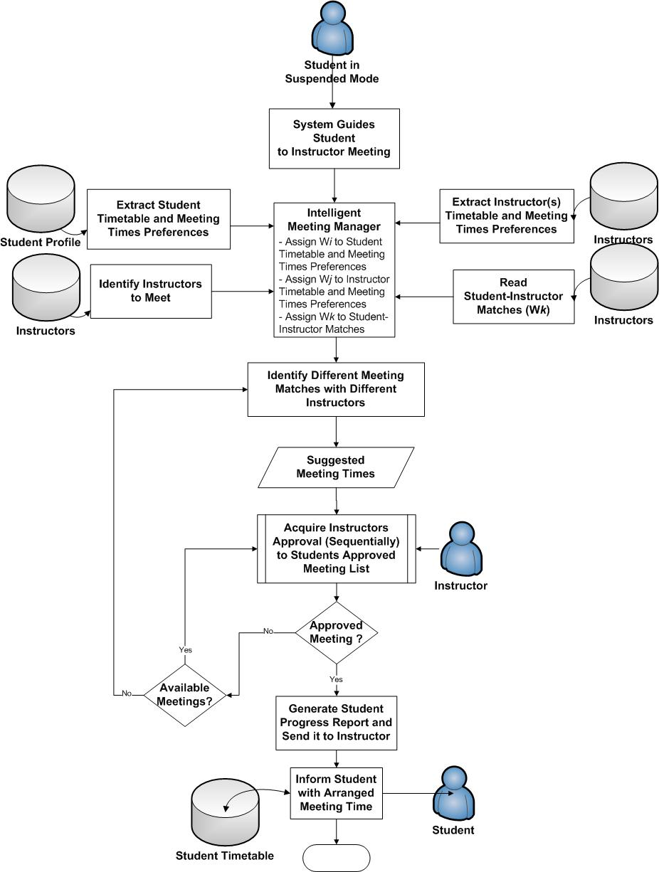

Figure 4.9: Intelligent Meeting Manager for Suspended Students Flowchart

* 1. **Summary**

Intelligent techniques to empower the proposed adaptive e-Learning models are presented in this chapter. Presented intelligent services utilize fuzzy logic to enable system acts intelligently. Presented intelligent services are grouped into two groups: Instructor, and Student intelligent services.

**The Instructor Intelligent Services are:**

* Intelligent Learning Object (LO) Classifier: used to classify LOs to categories. Useful with non-classified and new LOs presented to the system.
* Intelligent Online Lecture LOs Advisor: Advices instructors with the most suitable LOs to use during lectures. Considers attending students’ preferences in the inputs, and tends to enrich online lectures.
* Intelligent Student Tracker: track the students’ performances, and verify the completeness of students’ learning profiles.
* Intelligent Cheating Depressor: identifies peaks in students’ scores in the attempt to detect cheating instances.

**The Student Intelligent Services are:**

* Intelligent Time-to-Learn Topic Calculation: help students identify the time needed to finish study requirements for learning topics.
* Intelligent Study Plan Advisor: help students take decisions at course branches based on previous experiences for similar students.
* Intelligent Agenda Study Time Planner: help students manage their timetables by combining the lecture times, activity times, and suggested study times for LOs.
* Intelligent Meeting Manager for Suspended Students: arrange meetings for suspended students with instructors to help them re-join the learning.
* Intelligent LOs Recommender: recommends the suitable personalized LOs for students to study that best matches their learning preferences. Used in fulfilling pre-requisites, and in additional readings and further study.